A

Project Report on

**Crop Disease Detection and Crop Suggestion**

Submitted in partial fulfillment of completion of the course

Advanced Diploma in IT, Networking and Cloud

Submitted by:

**AKSHAY SURENDRAN**

**NAVANI P**

**SHARON P.A**

**SHUHAIB**

|  |  |  |
| --- | --- | --- |
| IBM-Logo - Chicago Innovation | DGT introduces high end diploma courses - digitalLEARNING Magazine | Edunet Foundation-Delhi- CSR Organization profile |

Year 2024

**Abstract:**

Developing countries like India face agricultural challenges due to crop diseases and unpredictable weather. Current methods for disease detection and crop selection are insufficient, leading to reduced yields and farmer vulnerability. This project aims to address these issues by creating an AI-based tool for crop disease detection and weather-based crop suggestions. By leveraging AI and real-time weather data, this tool will empower farmers with timely insights, improving agricultural productivity and sustainability.

**Acknowledgement:**

We would like to express our deepest appreciation to the talented team of developers, agronomists, and data scientists whose collaborative efforts and dedication have been instrumental in the creation of this tool. We are especially grateful to the farmers who participated in our testing phases and provided essential feedback.

**Table of Contents**

1. **Introduction to Problem:**

Agriculture is the backbone of many economies, particularly in developing countries where a significant portion of the population relies on farming for their livelihood. However, the agricultural sector faces numerous challenges, one of the most critical being crop diseases. Crop diseases can lead to substantial losses in yield and quality, severely impacting the economic stability of farmers and the food supply chain.

1. **Literature Review:**

Recent advancements in crop disease detection leverage machine learning (ML) and computer vision, with studies demonstrating over 99% accuracy using convolutional neural networks (CNNs). Real-time disease monitoring integrating IoT and ML has shown promising results. In crop suggestion, decision tree algorithms and data-driven approaches using soil, climate, and market data provide tailored recommendations. Remote sensing and GIS technologies are enhancing precision in crop monitoring and yield prediction. These technologies collectively advance sustainable agriculture and effective crop management

1. **Proposed Solution:**

Our proposed solution comprises an Automated Crop Disease Detection System and a Crop Suggestion Tool. The disease detection system leverages machine learning and computer vision to analyze images of crops and provide real-time diagnoses via a user-friendly mobile and web interface. The crop suggestion tool uses data analytics and machine learning to offer personalized crop recommendations based on soil health, climate conditions, and market trends. This integrated approach aims to enhance agricultural productivity and sustainability.

1. **Requirements:**

**Technology Stack:**

Image Recognition and Crop Disease Detection

1.Convolutional Neural Networks (CNNs)

2.Deep Learning

Weather-based Crop Recommendation

3.Supervised Learning

**Hardware:**

1.high performance pc

2.stable internet connection

**Software:**

Programming Languages and Frameworks:

**1.python**: As a widely-used language for machine learning and data science, Python will be a primary choice for the development of the AI models and backend components.

**2.TensorFlow** : These popular deep learning framework will be essential for building and training the image recognition and weather prediction models.

**3.Flask or Django**: Python web frameworks that can be used to develop the backend API and server-side logic.

1. **User Requirements:**

**Easy Image Upload**: Users must be able to easily upload images of their crops via a mobile or web application.

**Real-Time Disease Diagnosis**: The system should provide instant and accurate diagnoses of crop diseases based on uploaded images.

**Personalized Crop Suggestions**: Users should receive tailored crop recommendations based on soil data, climate conditions, and market trends.

**User-Friendly Interface**: The application must have an intuitive and accessible interface for both web and mobile platforms.

**Secure Data Handling**: Ensure secure storage and handling of user data, including images and personal information.

1. **Design Documentation**

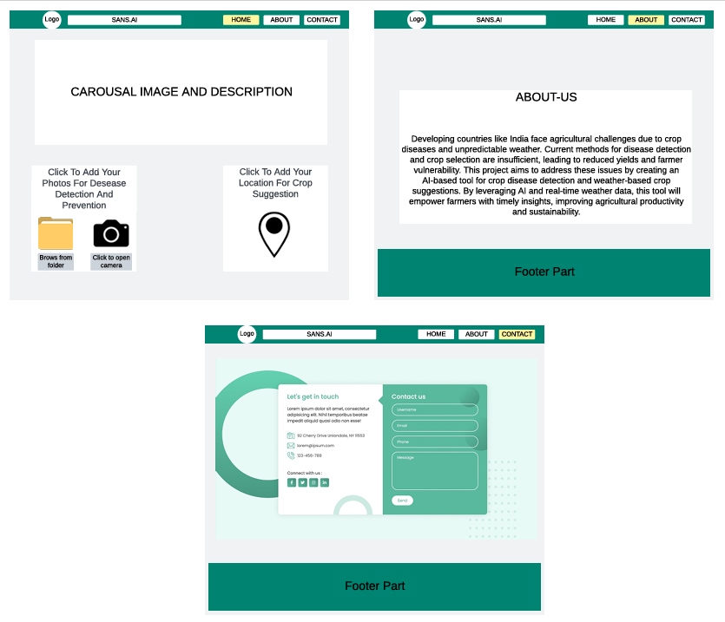

**7.Future Scope:**

**Integration with IoT Devices**: Expanding the system to integrate with Internet of Things (IoT) devices for real-time monitoring of crop health, soil conditions, and environmental factors, providing continuous data to enhance decision-making.

**Advanced AI Models**: Leveraging advancements in deep learning and AI to develop more sophisticated models that can detect a broader range of diseases and pests with even higher accuracy and at earlier stages.

**Expanded Crop Database:** Increasing the database to cover more crop varieties and diseases, making the tool applicable to a wider range of agricultural contexts globally.

**Predictive Analytics:** Implementing predictive analytics to forecast disease outbreaks and crop performance based on historical data and current trends, enabling proactive measures for disease prevention and crop planning.

**Multilingual Support**: Adding support for multiple languages to make the tool accessible to farmers in different regions, improving usability and adoption in diverse linguistic communities.

**Collaborative Platform**: Developing features that allow farmers to share data and insights, creating a community-driven platform for collaborative learning and support.

9. **Conclusion:**

In conclusion, the AI and ML-driven Crop Disease Detection and Crop Suggestion Tool promises to revolutionize agriculture by offering timely disease diagnoses and personalized crop recommendations. By leveraging advanced technologies like machine learning and computer vision, this tool enhances efficiency and accuracy in farming practices. Moving forward, expanding its capabilities with IoT integration and predictive analytics will further optimize crop management strategies. This tool not only aims to increase yield and profitability but also supports sustainable farming practices, contributing to global food security and the livelihoods of farmers worldwide.